DOCUMENT INFORMATION
PRODUCT NAME | TEMPO
‬PROJECT NAME | ‬TEMPO
PROJECT NUMBER | N/A

Table of Contents
1. Introduction 4
1.1. Purpose 4
1.2. Scope 4
1.3. Responsibilities 4
1.4. Methods, Tools, and Techniques 5
1.5. Definitions 5
1.6. Referenced Documents 5
2. Secure System Design 6
2.1. Secure Software Life Cycle and Security Requirements 8
2.2. System Diagrams 8
2.3. Interface Diagram 13
2.4. Network Security 14
2.5. Data Mapping / Security 16
2.6. Threat Model 17
2.7. Services Planned for Use 18
2.8. Interoperability 18
3. Secure Development Process 18
3.1. Detailed Designs of Security aspects 18
3.2. Secure Source Code 18
4. Cybersecurity Risk Management Plan 19
4.1. Cybersecurity Risk Analysis and Evaluation Method 19
4.2. Risk Control, Verification, and Residual Risk 20
4.3. Linkage to Product Safety Risk Management 20
4.4. Criteria for Cybersecurity Risk Acceptability (Software Release) 20
5. Product Security Testing 21
5.1. Testing During Development or Design Changes 21
5.2. Annual Security Testing 23
6. Maintenance Activities 23
6.1. Vulnerability Monitoring 23
6.2. Vulnerability Assessment 24
6.3. Incident response and Coordinated Vulnerability Disclosure 24
6.4. Security Patch Management Strategy 24
6.5. End-of-Support Planning of Software Components 24
7. Product Cybersecurity Action Plan 25
8. Appendix 25
9. Change Control 25
10. Content Approvals 25

Introduction

Purpose
Cybersecurity risk management is implemented across the total product life cycle (TPLC) and is integrated with the product’s quality and safety risk management processes. Cybersecurity risk management begins in early design with secure design principles and a structured threat model assessment. The process is iterative and is updated as the design evolves and as new threats, vulnerabilities, or environmental assumptions emerge. The plan also documents timelines for resolving open security issues.
A Secure Product Development Framework is applied to ensure cybersecurity is addressed throughout design, development, verification, release, and post-release maintenance. This includes proactive identification of assets, threats, vulnerabilities, cybersecurity risks; selection and verification of security controls; and continuous monitoring and response planning for identified post-market vulnerabilities.

Scope
This document provides the plan for cybersecurity risk management activities for Tempo product, software versions v3.2 and later.
Tempo is a non-cyber device.

Responsibilities
Deliverable/Activities | Activity Required | Person Responsible
Maintenance Activities | Defines and describes monitoring and patching activities, and an End of Support plan. | Thichava, Jeffrey
Product Security Plan | Defines and describes the allocation of risk management responsibilities, scope of plan, cybersecurity risk management activities, verification / validation of security controls, requirements for review of risk management activities, a post-launch risk monitoring plan, and any planned future risk mitigations. | Kunnel Vijayan,Thushara
Product Security Requirements | Enumerates and describes all cybersecurity controls in the product | Kunnel Vijayan,Thushara
Product Security Risk Management Report | Summarizes the risk management activities that took place and the overall residual risk level. | Kunnel Vijayan,Thushara
SBOM | Contains the list of 3rd party software components. | Thichava, Jeffrey
Security Verification | Define which test methods are performed. | Thichava, Jeffrey
Threat Model Report | Identifies and documents system assets and associates’ assets with applicable threats, assumptions about the intended environment, trust boundaries, data flows, and potential attack surfaces. | Kunnel Vijayan,Thushara

Methods, Tools, and Techniques
The following tools are used to support secure software development for Tempo: Veracode, Microsoft Threat Modelling tools and Cybellum.

Definitions
Refer to GLB-QS-REF-0053, Lexicon, for globally defined terms and definitions.
Refer to GLB-QS-PCD-0087, Product Security Procedure, for definitions specific to cybersecurity.
Term/Abbreviation | Description
ePHI | electronic Protected Health Information
Cross-Border Data Flow | The movement (or exchange) of data across borders.
Data Isolation | The physical, network, and operational separation of data to keep it safe from external cyberattacks and internal threats.
De-Identification | Ability of products to directly remove or anonymize the personal information contained in the data.
Least Privilege Access | The principle that a security architecture is designed so that each entity is granted the minimum system resources and authorizations that the entity needs to perform its function.
Product Restricted Data | Data that has handling restrictions resulting from regulatory constraints (ePHI, Personal, Medical) or business constraints (Intellectual Property)
SBOM | Software Bill of Materials is a list that includes but is not limited to commercial, open source, and off-the-shelf software and hardware components that are or could become susceptible to vulnerabilities.
SUPR | Software Update Patch Report.
Access WS | Access Workstation
SRS | Single Robot System
DRS | Dual Robot System
TCP/IP | Transmission Control Protocol / Internet Protocol
IO | Input Output
SAST | Static Application Security Test
VA | Vulnerability Assessment

Referenced Documents
Global documents:
- GLB‑QS‑PCD‑0087 – Product Security Procedure
- GLB‑QS‑PCD‑0059 – Non‑Product Software Validation
- GLB‑QS‑PCD‑0098 – Software Update Patch Procedure
- GLB‑QS‑PCD‑0047 – Product Safety Risk Management
- GLB‑QS‑PCD‑0002 – Product Obsolescence and Support Service Discontinuance
- GLB‑QS‑PCD‑0134 – Customer Feedback Handling
- GLB-QS-REF-0053 – Lexicon
- GLB‑QS‑TMP‑0290 – Product Security Threat Model Report
- GLB‑QS‑FRM‑0066 – Global Design Requirements
- GLB‑QS‑WI‑0181 – Review, Evaluation, and Investigation of Cybersecurity and Vulnerability Complaints
- GLB‑QS‑WI‑0183 – Coordinated Vulnerability Disclosure
Product records
- TEMPO-SBOM
- Tempo-Global Design Requirements
- Tempo Threat Model_V1.3.tm7
- Tempo Threat Model_V1.3.htm
- Tempo-Product Security Risk Management Report
- Tempo Software Development Plan
- DID Tempo
- DID Tempo Admin
- VER_SW Tempo Admin
- VER_SW Tempo Install
- VER_SW Tempo Protocols
- VER_SW Tempo Runs
- VER_VAL_SYS Tempo
- VER_VAL_SYS Tempo Admin

Secure System Design
The Tempo system is inclusive of mainly two user interfaces, one for Tempo users and another for Tempo Admins.
Primary customer-facing interfaces
Tempo User software will support:
• Creating and Editing Tempo Protocols
• Scheduling Tempo Protocols (including unattended)
• Plate Storage and Management
• Liquid and Plate mapping
Tempo Admin software will support:
• Managing and activating the Tempo license
• Device configuration and setup
• System setup
Additional interfaces (not primary customer-facing)
Device-specific client applications
• These are instrument-focused control/configuration interfaces used for specific integrations, for example:
AmbiStore, ASM, Echo Mass Spec, Envision Reader, Inheco, Cytomat, Combi, Certus, PressSeal, Tempest, Teleshake, VCode, VSpin, XPeel, VolumeCheck, LightCycler, MicroServe, and PlateLoc-related clients.
Viewer interfaces
• Schedule Viewer-type tools used to inspect planned, running, completed, and archived runs.
In dynamic fashion, Tempo User software manages all tasks—including sample management, plate handling, liquid handling, and detection without custom programming or scripting. Included with all Access systems, Tempo software is the only platform that allows researchers to rapidly create automation routines incorporating protocols developed with Labcyte Echo® software applications. The software directly imports protocols created with Echo® software applications and guides users to build fully automated plate handling routines from the Echo liquid transfer protocols. The software can also be used to perform plate processing tasks, such as plate centrifuging and plate sealing.
Tempo Admin is mainly used by Field Service Engineers for configuring and setting up a Tempo system on Access WS, SRS, or DRS. While it can be launched by a customer, the intended audience is someone who has been trained on Tempo installations and has the necessary devices.
Tempo connects to devices via Ethernet (TCP/IP) and uses multiple communication protocols for device-specific commands. There may be several integrated devices connected to the Tempo system including plate storage systems, robotic arms, barcode readers, centrifuges, de-lidders, and thermal cyclers, all communicating over isolated laboratory networks.

Secure Software Life Cycle and Security Requirements
The secure software lifecycle for Tempo is implemented in accordance with the agile development lifecycle defined in the Tempo Software Development Plan. Security activities are integrated throughout requirements, design, implementation, verification, release, and maintenance phases.
Security and privacy requirements are identified during requirements definition and are addressed through architectural design, controlled implementation practices, peer code reviews, and system-level verification activities. Secure design considerations are documented within the software architecture and security-relevant controls are verified as part of integration and system testing.
Changes and defects are evaluated through formal change control and risk management processes, including assessment of potential security impact. Applicability of security requirements to software, firmware, and supporting third-party components is documented through controlled requirements, SBOM records, and cybersecurity risk management documentation.

System Diagrams
High level architecture diagrams of the major functions and modules of the system are given below.
Two primary software packages control the system: Tempo for run execution and workflow management, and TempoAdmin for device configuration and system administration. Both Tempo and TempoAdmin store their data using Microsoft SQL Server with Windows Authentication, maintaining device configurations, run protocols, plate inventory, and audit trails in the database. Application settings are stored in Windows application configuration files, and device capability definitions are stored as XML in the database. The applications also maintain extensive log files for device communication, run execution, and error tracking on the filesystem.
The user interacts with the software through the Tempo workstation user interface running Windows. The system operates in physically secured laboratory environments, with all device communication occurring on private network.
As shown in Figure 1, the Host PC and OS Environment diagram illustrates the software and operating system environment in which Tempo is installed and executed.
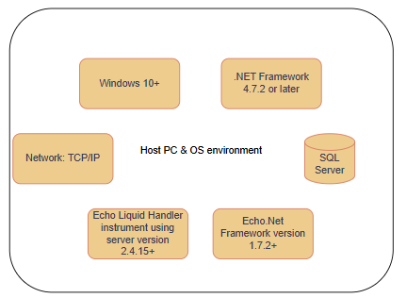
Figure 1: Host PC & OS Environment

Figure 2 illustrates the high-level data flow between the main Tempo components, including the user-facing interfaces, data store, scheduling and execution services, device drivers, plate management, run logging, and email notification functions. It shows how users and administrators configure the system, how protocols are created and saved, how runs are picked up and executed, and how status, logs, and notifications are generated during operation.
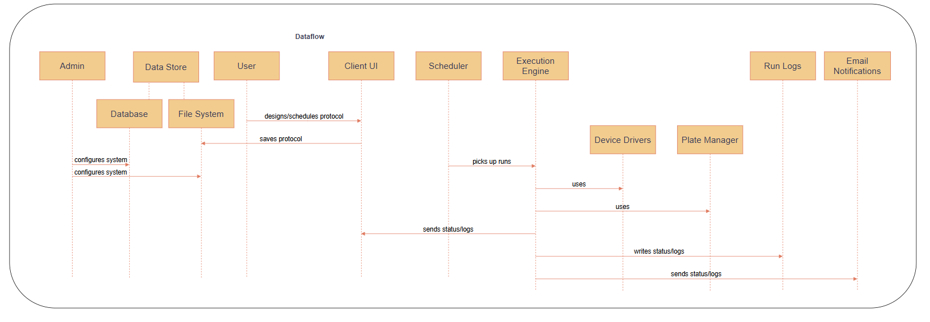
Figure 2: Tempo Dataflow

Figure 3 illustrates the communication interfaces between Tempo and the external systems it depends on, including SILAS-based module integrations, vendor libraries, MS SQL Server, report and run-log storage, and the Tempo Schedule Viewer utility. It shows the communication mechanisms used by Tempo, such as TCP/IP, serial or Ethernet connections, ActiveX/DLL library calls, and file system I/O.
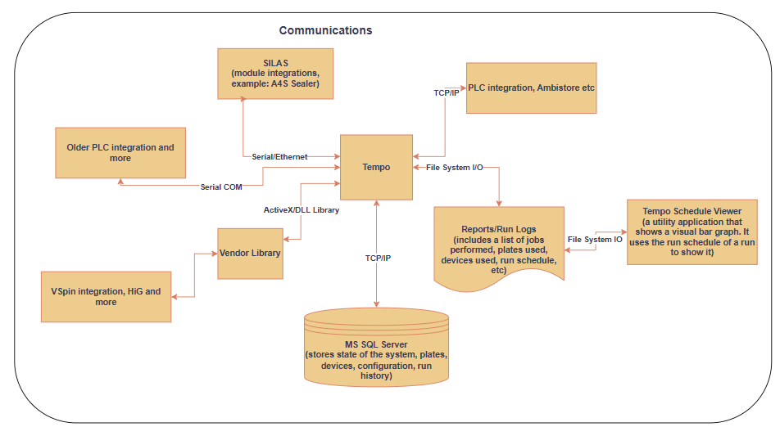
Figure 3: Comminications
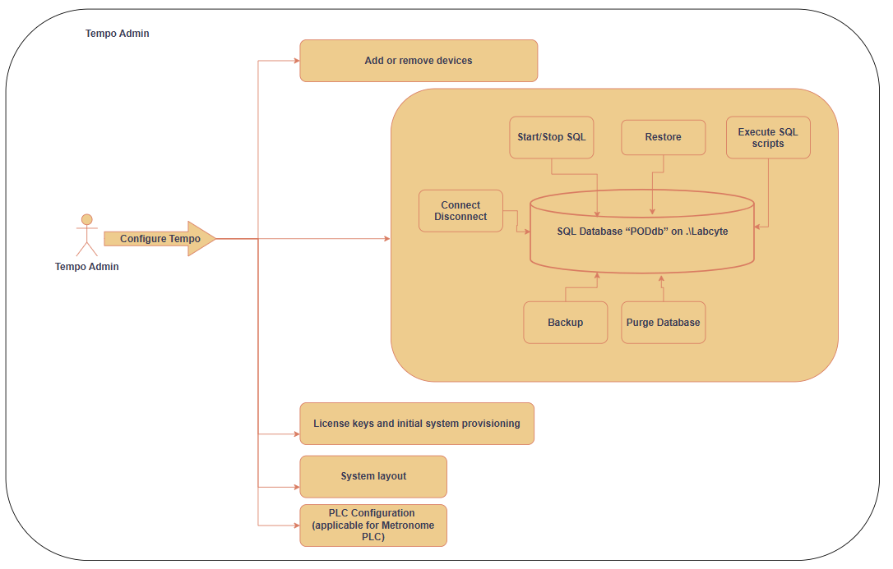
Figure 4: Shows how Tempo Admin supports system configuration and SQL database management during setup and maintenance.

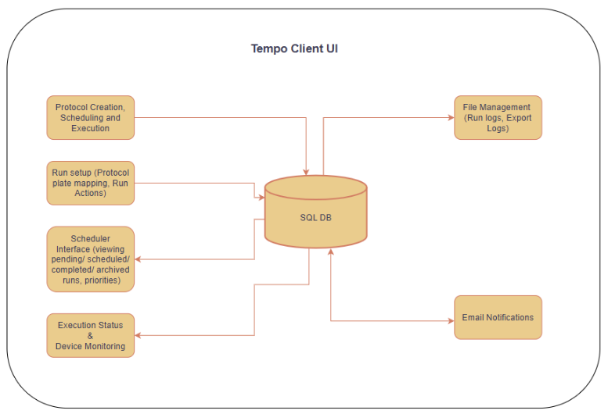
Figure 5: Tempo Client UI Workflow and Data Interactions

Interface Diagram

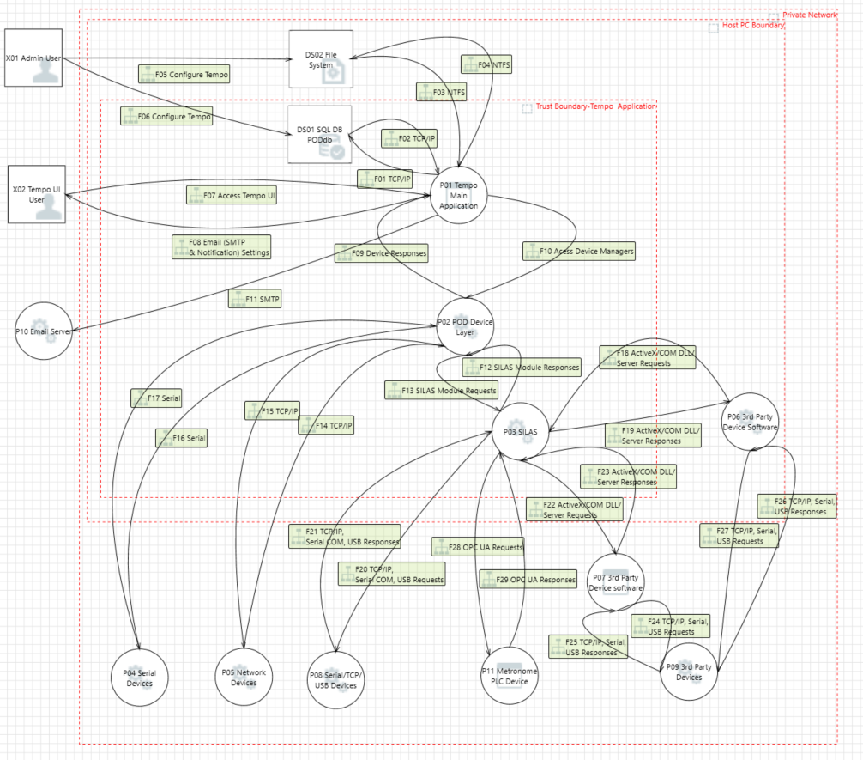
Figure 6: Interface Diagram
The above diagram (Figure 6) shows the general interfaces between modules of the system. No wireless interfaces are present; all communications are through wired interfaces only.

Network Security
The Tempo system operates from a laboratory workstation PC that is typically deployed on isolated laboratory networks. The workstation PC is configured with Windows Firewall, with its detailed settings to allow outgoing connections to devices, PLC, SQL Server etc. Tempo does not host any server services or accept inbound network requests. The system communicates outbound via TCP sockets to devices on fixed IP addresses, Modbus TCP to PLCs, direct serial connections (COM ports) to devices such as barcode readers and SMTP over configured ports (in UI) for email notifications to configured mail servers. All device communication occurs on private laboratory subnets. Serial device communication bypasses the network entirely, using direct physical cable connections to USB-to-serial adapters or native serial ports. No modifications to Windows Firewall rules are required by the Tempo installer.
A Tempo with Echo integration network diagram is added below (figure 7) because 90% of Tempo systems have at least one Echo.

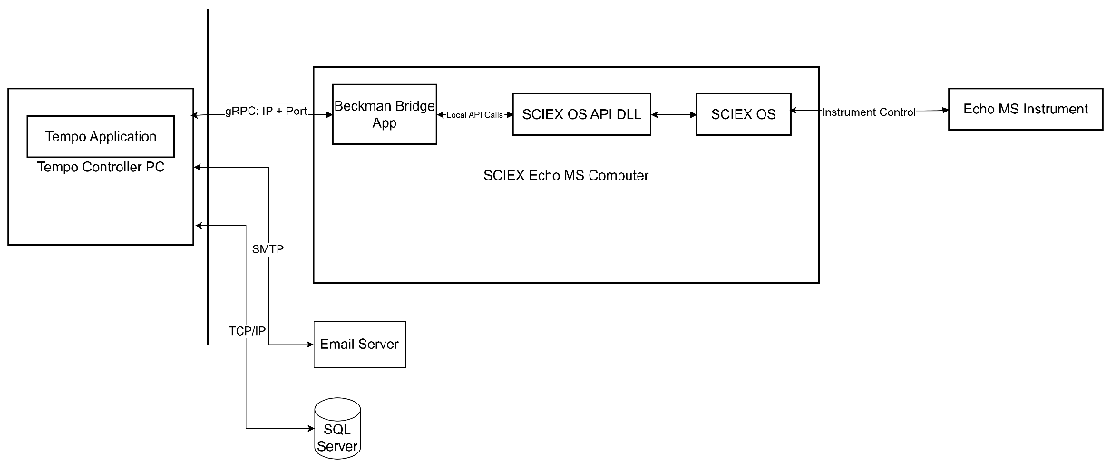
Figure 7: Network diagram of Tempo with Echo integration

Data Mapping / Security
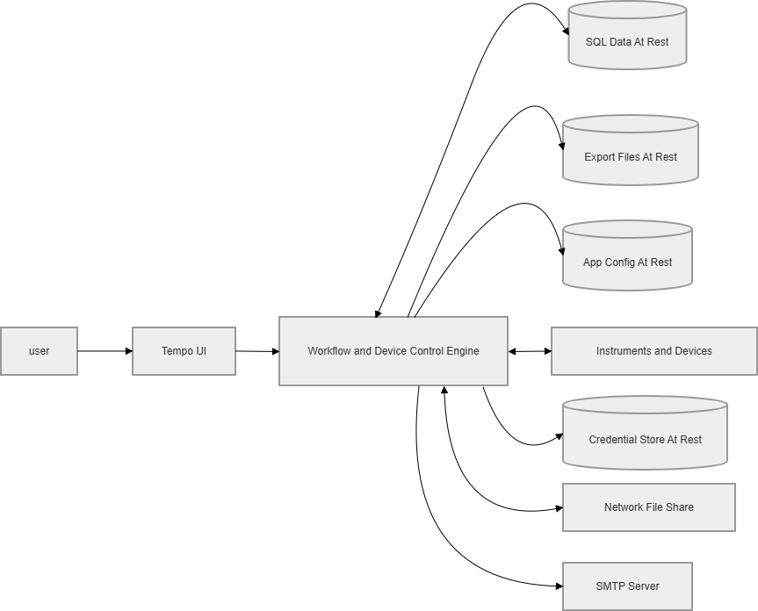
Figure 8: Tempo Data Flow Across System Elements for Security Control Identification

The table below lists the kind of data (described above) that is on or traveling through each system element. This helps clearly identify the security controls needed to protect the data.
System Element/Assets  (Location) | Data At Rest /  Data In-Transit | Classification | Encryption Required? | Characteristics  (e.g., Export, Audit Log)
SQL Server: Database | Protocol definitions, Plate mappings, Instrument parameters | Device data | No | Exportable: Yes  Backup: Yes  Local Service: Yes  Remote Service: No
SQL Server: Database | Run execution logs,  Timestamps | Audit Logs | No | Exportable: Yes  Backup: Yes  Local Service: Yes  Remote Service: No
File System: Export | Reports: Run logs, Audit logs, CSV exports, Protocol files | Device operational Data and Logs | No | Exportable: Yes  Backup: Yes  Local Service: Yes  Remote Service: No
SMTP: Email Server | Credentials: SMTP Username, SMTP Password (encrypted), Email content: Run notifications | Sensitive Credentials | Yes | Exportable: No  Backup: No  Local Service: No  Remote Service: Yes
SQL Server: Authentication | Credentials: Windows domain credentials (OS-managed) | Confidential - Identity/Security | Yes | Exportable: No  Backup: No  Local Service: Yes  Remote Service: No
File System: App Config | Configuration: Application settings, Default values | Internal Configuration | No | Exportable: No  Backup: Yes  Local Service: Yes  Remote Service: No
Network: Device Communication | Commands: Protocol execution, Plate transfer parameters, Instrument status, Error messages | Device Operational Data | No | Exportable: No  Backup: No  Local Service: Yes  Remote Service: No

Threat Model
Threat modeling for the Tempo system software was performed using the STRIDE methodology to identify potential threats related to Spoofing, Tampering, Repudiation, Information Disclosure, Denial of Service, and Elevation of Privilege. Through team discussions and collaborating with GPS team identified threats are either mitigated or accepted. The Microsoft Threat Modeling Tool was used to create and document the threat model based on the system architecture, data flows, trust boundaries, and identified mitigations.

Threat Model (TM file) | Tempo Threat Model_V1.3.tm7
Threat Model Report (HTM file) | Tempo Threat Model_V1.3.htm

Services Planned for Use
The Tempo codebase uses the following services and external interfaces:

- Windows service operation for SampleStore integration, implemented as a Windows Service and run via ServiceBase for background polling and run definition generation.

- Network communication services using TCP-based interfaces, including net.tcp WCF endpoints and configurable IP/port-based device connectivity.

- Network file share access for integrations that read/write image or data files through UNC paths.

- Local device communication over COM port, including USB-to-serial connectivity for VolumeCheck.

- Local printing functionality for protocol and run-related views in the Symphony application.

- SMTP-based email notification capability through configurable mail server host, port, SSL, and credentials.

No unnecessary background services are enabled on the operating system, and access to operating system-level services is restricted.

Interoperability
The Tempo interoperates with customer networks, various devices configured for its use and device’s server software’s in the network. Interoperability is limited to configuration-based enablement. Associated cybersecurity risks are evaluated and managed through system design controls, threat modeling, and cybersecurity risk management activities.

Secure Development Process
This section describes how secure development process practices are planned, implemented, verified, and documented throughout the product lifecycle.

Detailed Designs of Security aspects
As Tempo is a non-cyber device, no Security Architecture documentation is necessary.
Secure design documentation describing modules, interfaces, and trust boundaries is included in this document and is stored in the EDMS under Cabinets/Product Development/Design History and Project Files/Life Science Automation/Acoustic/Tempo/Product Security.

Secure Source Code
Product security requirements are traced to verification tests. All developers are annually trained on secure coding standards, as defined in GLB-QS-REF-0097 Secure Coding. All product code is subject to peer review before merging, as defined in Tempo Software Development Plan.
All third-party software is recorded in Tempo SBOM subject to Legal approval per GLB-QS-PCD-0048 Software Development Procedure. Third-party software is additionally subject to SCA using the tools described in section 1.4 of this document. The SCA identifies vulnerabilities and EoS per GLB-QS-PCD-0087 Product Security Procedure and its results are incorporated into Tempo-Product Security Risk Management Report. These analyses are conducted regularly as described in section 5 of this document.
The final patches to third-party software before release are gathered and applied as late as reasonably possible before building a release candidate image for verification. Patches may be applied after this point as decided by the CRB based on a risk assessment of newly discovered vulnerabilities.

Cybersecurity Risk Management Plan
Cybersecurity risk management evidence is maintained in controlled records that provide end-to-end traceability from assets and threats to vulnerabilities, security controls, verification activities, and residual risk acceptability. The Tempo-Product Security Risk Management Report documents all unmitigated vulnerabilities from any source.
Cybersecurity risks are identified using multiple activities. Once threats are identified, third-party software components (including open-source and commercial off-the-shelf components) are assessed for known vulnerabilities. Vulnerabilities are addressed through secure design and development practices and through application of security controls.
Risk detection activities use the following inputs, as applicable:
- Threat modeling and architecture review
- Review of third-party software components for known vulnerabilities (e.g., SBOM-driven checks / software composition analysis)
- Secure code review and static analysis (e.g., SCR/SAST)
- Vulnerability assessment (VA), including configuration and dependency scanning
- Penetration testing (PenTesting), including abuse-case testing informed by the threat model
- Review of security-relevant defect reports from development and verification
- Review of customer feedback, vulnerability disclosures, and security advisories (as applicable)
Outputs of these activities (identified vulnerabilities) are consolidated, de-duplicated, and tracked to remediation and verification.
For new products, a Cybersecurity Risk Management Report is released prior to Design Transfer Review. The Cybersecurity Risk Management Report is updated for Design Changes that affect cybersecurity risks.

Cybersecurity Risk Analysis and Evaluation Method
Analysis and evaluation of applicable cybersecurity risks and potential impacts to safety and security based on:
- The threats identified in the Threat Model,
- Vulnerabilities identified through risk detection activities, and
- The potential clinical and operational impacts if a risk were exploited.

Vulnerabilities are scored using CVSS 3.1 standard when manually scored or via the results of validated tools in either quantitative or qualitative results (high, medium, etc.).

Determination of whether a risk can be mitigated should consider the operating environment and the security controls and mitigations that exist or will be in place at release.

Risk Control, Verification, and Residual Risk
For each cybersecurity risk, risk control measures are selected and implemented using defense-in-depth principles as appropriate. Controls may include secure architecture choices, authentication/authorization, cryptographic protections, hardening, secure update mechanisms, monitoring, and other protective measures commensurate with the risk.
Each implemented control is verified for correctness and effectiveness through appropriate verification activities (e.g., requirements-based testing, security testing, VA, PenTesting).

Linkage to Product Safety Risk Management
Cybersecurity risks with potential impact to safety, including safety of laboratory personnel, are identified and communicated to the safety risk management team. The safety risk management team is notified for confirmation and for association with a new or existing System Risk Assessment (SRA) item according to the Product Safety Risk Management procedure, GLB-QS-PCD-0047.
Each cybersecurity risk is assessed to determine whether there is an associated potential safety risk. This is documented in the Risk Management Report Section 3.2. Cybersecurity-derived safety risks are assessed and managed as part of the overall product safety risk management process.

Criteria for Cybersecurity Risk Acceptability (Software Release)
The cybersecurity risk of a product software release is considered acceptable if one of the following criteria can be demonstrated:
- All residual, unmitigated cybersecurity risks, including those rated Very High, High, Medium, and Low severity, are documented with mitigating circumstances and rationale.
- If any residual Critical or High severity cybersecurity risks remain, the potential impact to operator safety, device security (confidentiality, integrity, and availability of data), and privacy must be described in the Tempo-Product Security Risk Management Report. Workarounds that may be applied by the customer or service to mitigate risk in the absence of a design control should be provided if available.
- The release is a software patch to a previously released product, and the scope is limited to one or more of the following:
  - Mitigation of cybersecurity risks for customers and/or patients.
  - Mitigation of safety risks for which a field action is required.
  - Support of hardware changes due to hardware obsolescence.

Risk acceptability decisions, evidence, and any required compensating controls, are documented in the Risk Management Report and are subject to appropriate review and approval.
The residual risk and rationales for accepting vulnerabilities are provided with the approval in the Tempo-Product Security Risk Management Report.

Product Security Testing
All security requirements are validated as part of the product’s design verification and validation activities in accordance with the applicable Design Verification Plan and Design Validation Plan.
- Veracode scans: Perform static and dynamic analysis using Veracode to scan for vulnerabilities such as SQL injection, cross-site scripting (XSS), and other security flaws in both source code and runtime behavior.
- Internal Penetration Testing: Conduct thorough penetration tests to simulate real-world attack scenarios. Identify potential entry points and test the system's response to various attack techniques. External penetration testing is not required for this product.
- Nessus Scan: Use Nessus to perform vulnerability assessments on binary executable files and dependencies. Identify and assess vulnerabilities in third-party libraries and components

Testing During Development or Design Changes
SAST activities, using the latest applicable security benchmarks, are automated on the build server for each build. Final scans are performed on the release candidate and recorded in the Tempo-Product Security Risk Management Report.
Vulnerability assessments will be conducted annually, with additional assessments following major updates or patches.
Penetration tests will be conducted annually and after any significant architectural changes to the application.

5.1.1. Vulnerability Assessment (VA)

Description | Identifies vulnerabilities in the system during runtime.
Team Responsible | Product Security Team
Scheduling | For new products and products with design changes, conduct a vulnerability assessment using the Nessus tool after code freeze. For maintenance products without design changes within the year, conduct a vulnerability assessment using the Nessus tool before the annual penetration test.
Method
  The system is scanned using Nessus tool to detect potential vulnerabilities. The findings are reviewed, assessed for impact, and remediate where necessary.
Outcome | Identifies the security Vulnerabilities in the system.

5.1.2 Static Application Security Test (SAST)

Description
  Identifies vulnerabilities, coding errors, and security issues in the application code and runtime behavior.
Team Responsible | Product Software Team
Scheduling | Before each merge into the master branch.
Method
  A SAST scan will be performed using Veracode to capture a baseline set of issues in the existing code base. These issues will be assessed for accuracy and relevance. All relevant issues will be evaluated and mitigated through the Tempo-Product Security Risk Management Report.
Outcome
  The vulnerabilities in the source code will be mitigated.

5.1.3 Penetration Testing

Description
  Penetration testing is conducted by a cybersecurity expert using a variety of tools to assess the product and its associated software components for security weaknesses and vulnerabilities.
Team Responsible | Global Product Security Team
Scheduling | Pentest is executed before the project moves to Qualification.
Method
  The penetration test is a simulated attack against the product to identify and characterize security-related issues via tests that focus on discovering and exploiting security vulnerabilities in the product. This testing also performs:
  - Abuse and misuse testing.
  - Attack surface analysis, including review of exposed interfaces and trust boundaries.
  - Vulnerability chaining assessments to evaluate how multiple weaknesses could create compound risks.
  - Closed‑box scanning using known vulnerability scanning tools (no internal code or design visibility).
  - Credential exposure
  - Encryption use and misuse
  - API misuse and injection issues
Outcome
  Identifies the Vulnerabilities in the system.

5.1.4 Feature Testing

Description
  We perform feature testing by identifying the feature, creating test cases (including abuse or misuse cases covering malformed and unexpected inputs, robustness), executing them, and verifying if the feature works as intended.
Team Responsible | Product Software Team
Scheduling | This is done with every software release
Method
  Execute the feature testing process by validating its behavior against predefined requirements using diverse inputs, including edge cases and erroneous data.
Outcome
  The application functions in accordance with its intended design and specifications.

Annual Security Testing
Annual PenTests are executed by the GPS team after being planned and scoped in a joint effort with Tempo Development. Following the PenTest, the results are jointly documented by GPS and Tempo Development. The PenTests are scoped per GLB-QS-PCD-0087 Product Security Procedure. Results from the latest PenTests are used in subsequent updates to Tempo-Product Security Risk Management Report and findings which require actions such as updating or changing 3rd-party components are recorded as tickets in Jira. These are then in turn communicated to the Change Review Board for purposes of planning upcoming releases.

Maintenance Activities
Cybersecurity risk management continues post-release through vulnerability monitoring and response processes. Relevant security information sources (e.g., vulnerability databases, supplier notifications, coordinated vulnerability disclosures, and field feedback) are monitored to identify new vulnerabilities and emerging threats. When vulnerabilities are identified, they are triaged, assessed for impact, and addressed through remediation and/or compensating controls within a reasonable timeframe commensurate with risk, including delivery of security updates or patches where applicable.

Vulnerability Monitoring
- Customer Feedback will follow GLB-QS-PCD-0134 Customer Feedback Handling.
- Vulnerability Complaints will follow GLB-QS-WI-0181 Review, Evaluation, and Investigation of Cybersecurity and Vulnerability Complaints.
- Externally reported vulnerabilities, including reports that do not meet incident criteria, will follow GLB-QS-WI-0183 Coordinated Vulnerability Disclosure.
- The Global Product Security team will systematically manage SBOM risks through the bi-annual security routine patch release process. The Cybellum tool is used to scan SBOM components for vulnerabilities, with data sources covering GHSA, NIST/NVD, and CVE common vulnerability disclosures. Detected vulnerabilities will be promptly assessed and a remediation plan will be formulated, which will be documented in the SUPR document every 6 months and uploaded to EDMS for archiving.

Vulnerability Assessment
Newly discovered vulnerabilities are first assessed by Development, with Product Security and Quality reviewing and approving the assessment. Vulnerabilities and their dispositions are tracked in Tempo-Product Security Risk Management Report. Operating system and platform-level vulnerabilities affecting the Beckman-provided Biomek i-Series workstations are managed by the R&D team through the SUPR process. The R&D team completes the Security Update Patch Report (SUPR) on a quarterly basis. They are stored in the following EDMS folder: Cabinets/Product Development/Design History and Project Files/Life Science Automation/Liquid Handlers/LH6525_Biomek NXp_FXp Refresh/2. DESIGN HISTORY FILE/2.05 Design and Development/2.5.5.a System Evaluation/2.5.5.1 Product Privacy and Security Risk Assessment

Incident response and Coordinated Vulnerability Disclosure
Cybersecurity incidents and externally reported vulnerabilities are managed in accordance with GLB-QS-WI-0183 Coordinated Vulnerability Disclosure. Customer notification and response activities are performed when required based on risk evaluation and regulatory obligations.
Investigation outcomes and remediation actions are documented through established quality and change control processes.

Security Patch Management Strategy
Security patches for operating system, application software, and firmware are managed following GLB-QS-PCD-0098 Software Update Patch Procedure. Critical patches are addressed on an expedited basis, while routine updates are developed and released through planned update projects.
Patches are installed by trained service personnel using validated installation methods. Tempo does not support customer-applied automatic updates.

Describe Overall Security Patch Strategy:
Tempo is provided on Beckman-provided workstations based on the Biomek i-Series image. Please refer to the Biomek i-Series P&S Plan (DD-16575-AS1370-14 Biomek i-Series Product Privacy and Security Plan - section 3.7. Security Patch Management Strategy) for the overall security and Patch Strategy.

Describe Patch Distribution Strategy:
Windows Update is enabled on the controller PC. The version of Windows is a long-term servicing channel version. Microsoft provides monthly quality updates via Windows Update, inclusive of security updates. There is no additional oversight or involvement from the company required.
Patches to Tempo will be distributed to customers on USBs or electronically delivered to Service Engineers who would do the update.

End-of-Support Planning of Software Components
End-of-support status for software components, operating system elements, and firmware is monitored using SBOM documentation and vendor lifecycle information. Identified end-of-support risks are evaluated and addressed through upgrade, mitigation, or discontinuance planning in alignment with GLB-QS-PCD-0002 Product Obsolescence and Support Service Discontinuance.

Product Cybersecurity Action Plan
All existing unresolved vulnerabilities, including tracking ID, vulnerability description, and asset details are as follows
ID | Requirement | Description | SW Component/Asset
ISON-1337 | Encryption | Upgrading MD5 to sha256 is expected | Tempo Software
ISON-1335 | Password Management | Hardcoded Password | Tempo Software
ISON-1333 | Security Patch Management Strategy | Vulnerabilities detected in 3rd party library BTILHCRunner | Tempo Software
ISON-1334 | Security Patch Management Strategy | Vulnerabilities detected in BeckmanCoulter.Devices.SampleStore library | Tempo Software
ISON-1332 | SQL injection | SQL Injection vulnerabilities detected by Veracode | Database
ISON-1338 | OS Command Injection | OS Command Injection vulnerabilities detected by Veracode | Tempo Software

- Appendix
This section is not required for and does not apply to this document.‬
- Change Control
‬Revision | Author | Change Location | Change Description and Reason
«version_label» | Thushara Kunnel Vijayan | N/A | Initial Revision
- Content Approvals
My electronic signature confirms my approval of this document for its intended use.
APPROVALS: APPROVED ON: (mm-dd-yyyy)
«approver1 » «approve_date1 »
«approver2 » «approve_date2 »
«approver3 » «approve_date3 »
«approver4 » «approve_date4 »
«approver5 » «approve_date5 »
«approver6 » «approve_date6 »
«approver7 » «approve_date7 »
«approver8 » «approve_date8 »

